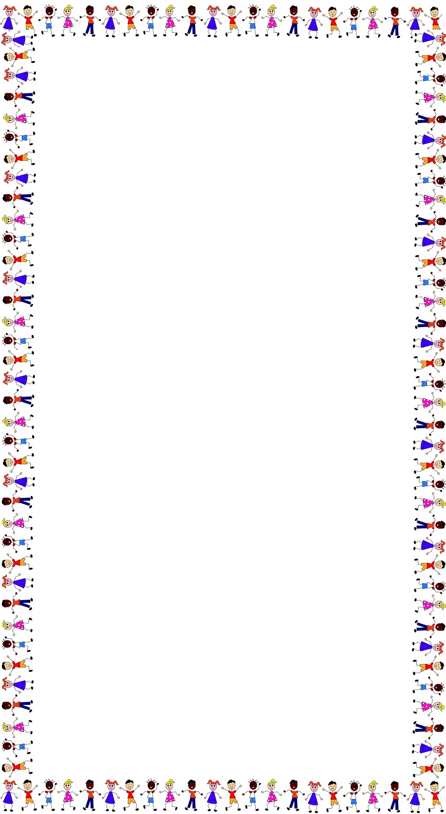
PUT THE VERBS IN THE CORRECT FORM OF THE PRESENT CONTINUOUS
1 . My sister_______________________ (play) in her bedroom
2. They ________________________ (go) to school.
3. My neighbours ___________________________ (watch) television.
4. The students ___________________________ (revise) for their test tomorrow.
5. The teacher ____________________________ (explain) the lesson again.
6. I_______________________________ (not/ play), I ____________________ (work) !
7. My dog _______________________ (run) after my cat in our garden.
8. Many animals ___________________________ (disappear) nowadays.
9. The kids _________________________ (hold) their hands.
10. My father_______________________ (try) to repair our car !
11. It____________________________ (not /snow) because it is too hot !
12. I__________________________ (read) a very interesting book at the moment.
13. Look ! Some people ________________________ (make) a film in the street .
14. ____________you _________________ (joke) ?
15. My sisters_________________________ (chat) with their friends !
16.- Who ______________________________(miss) today ? -Mike, Miss
17. We ______________________________ (learn) to drive.
18. My mother is __________________________ (cook) in the kitchen.
19. My brother __________________________ (tidy) his bedroom.
20. Many people _______________________ (move) because of the rise of the sea level.
21. They ______________________________ (look) for a new house.
22. I ______________________________ (look) for my keys, where are they ?
23. Sandy _______________________________ (look) after her baby brother .
24. We _______________________________ (look) forward to the next holidays.
25. Some people __________________________ (look) at that new building !

